Michael Hernandez  
CSIT340 Section 2 Computer Networks  
Socket Programing String Service 2 Project Report

Below are the screenshots of the tests I did to confirm that the programs work successfully. The first is shows that my non multithreaded TCP server works.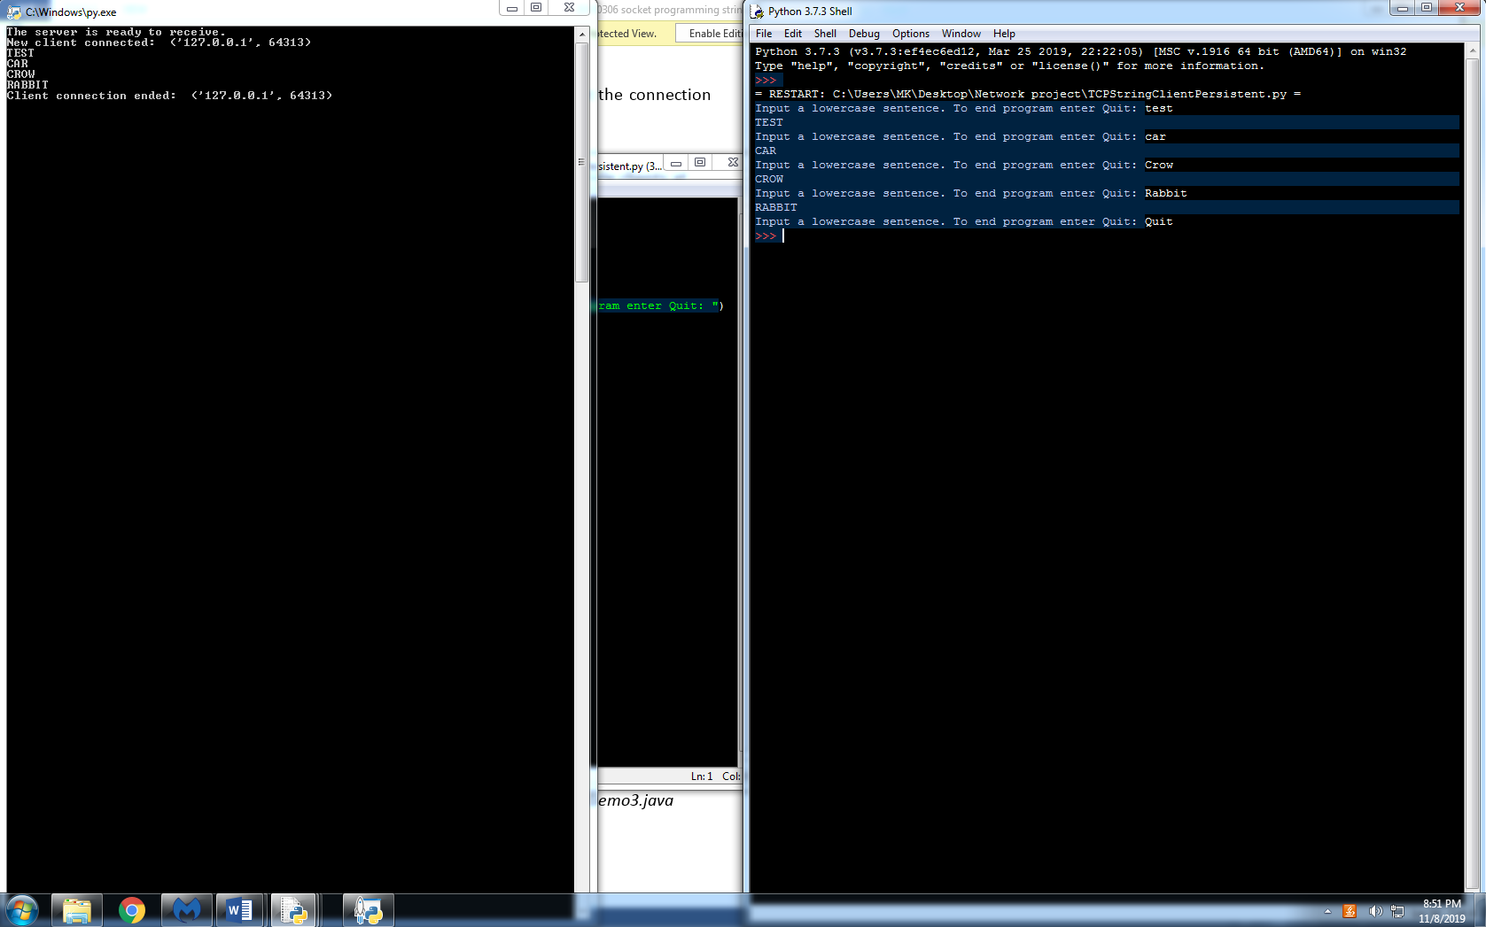

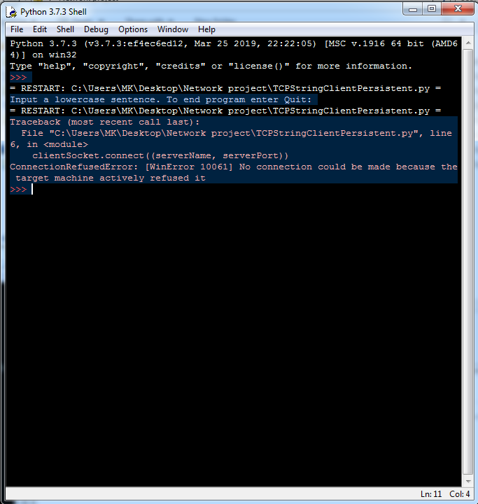And a screnshot showing that the nonthreaded tcp server will not accept more than one connection.

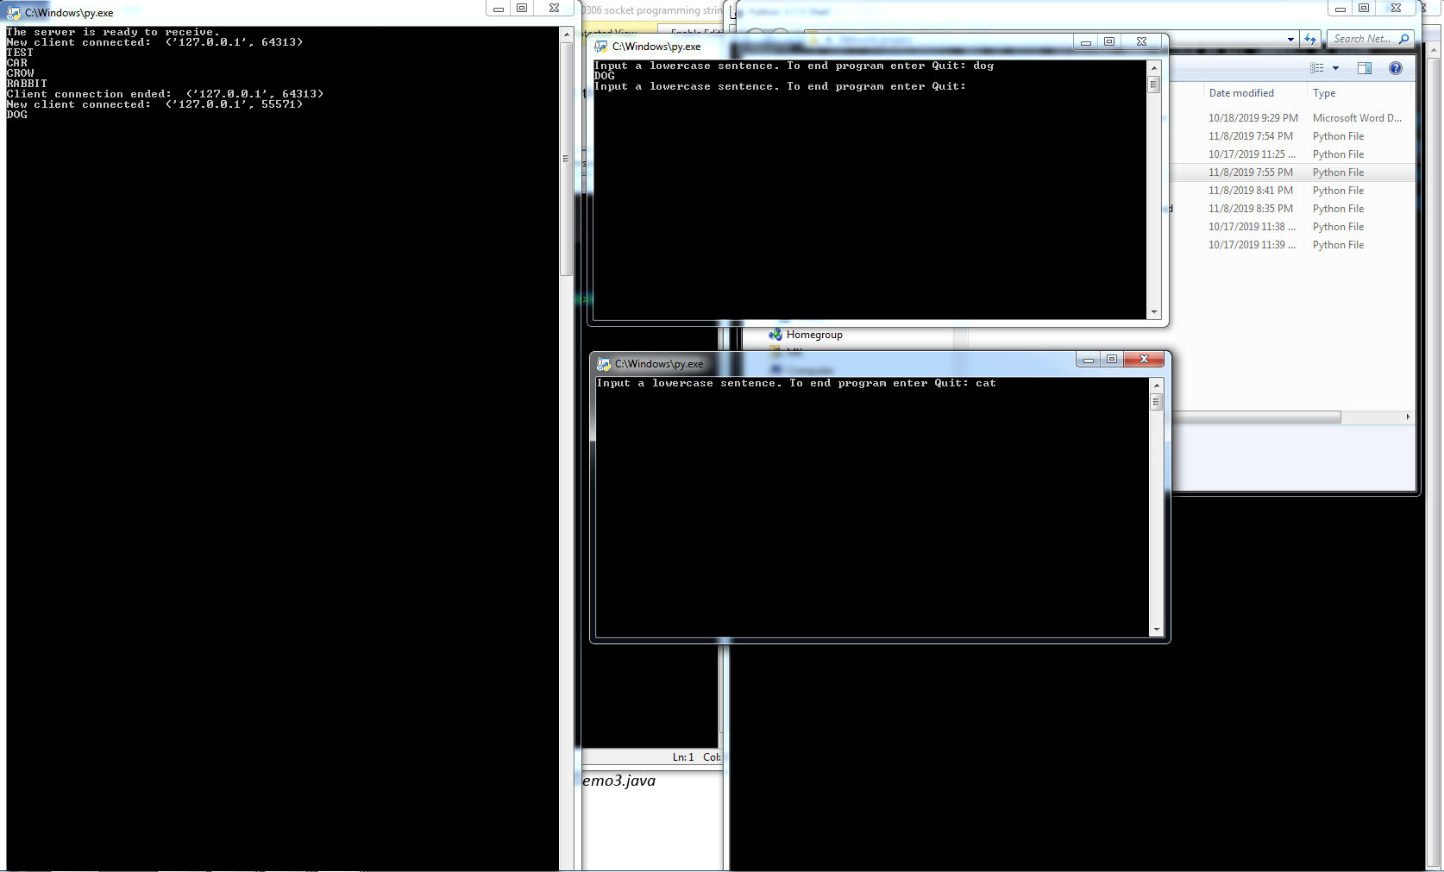Again showing that the tcp server will only accept one connection at a time, as well as showing the server will stay around to accept more connectiontions

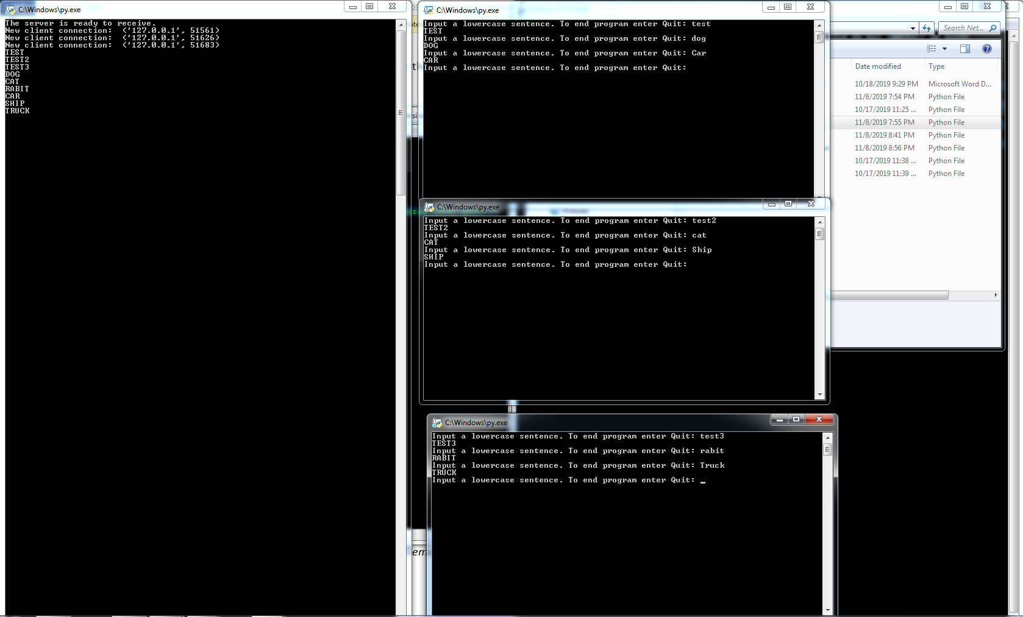This is my multithreaded test. As see, the server can accept more than one connection at a time.

The next 2 screenshots show what happens when you quit or close a client.

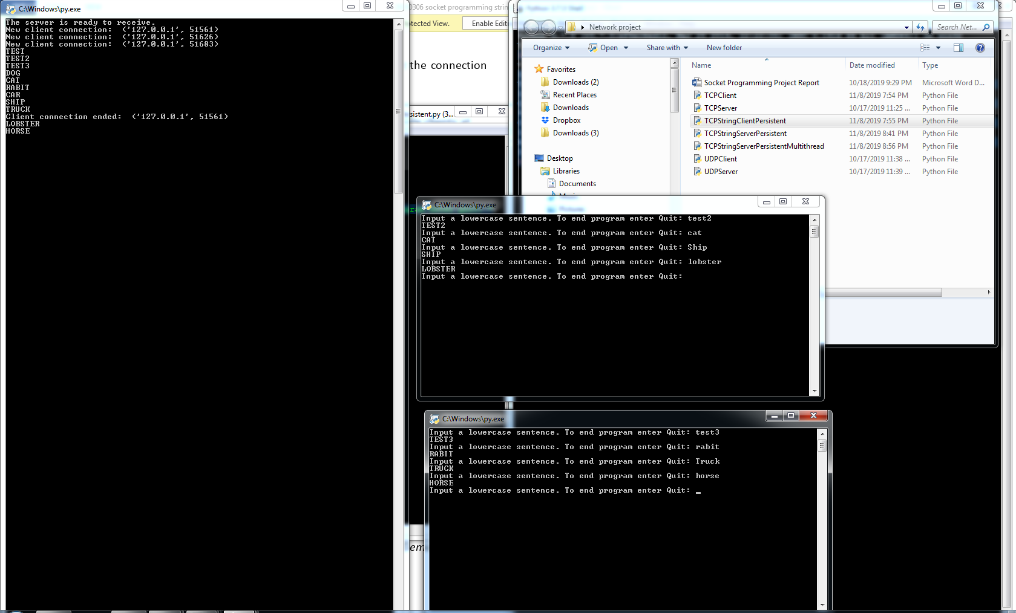

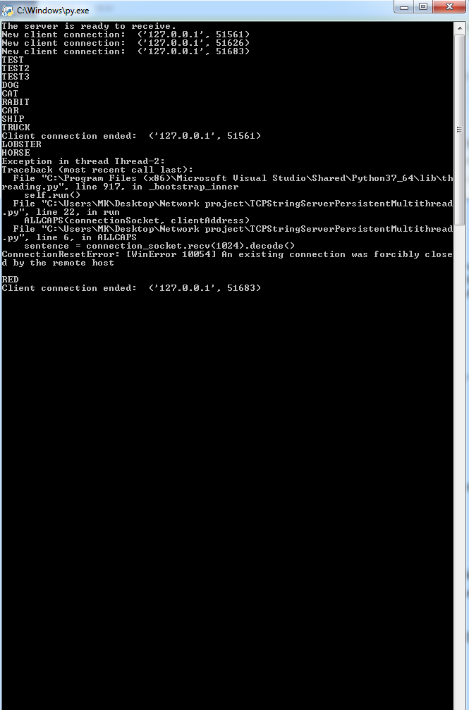

And to the last screenshot shows that it will continue to accept multiple connections after closing the previous connections.

